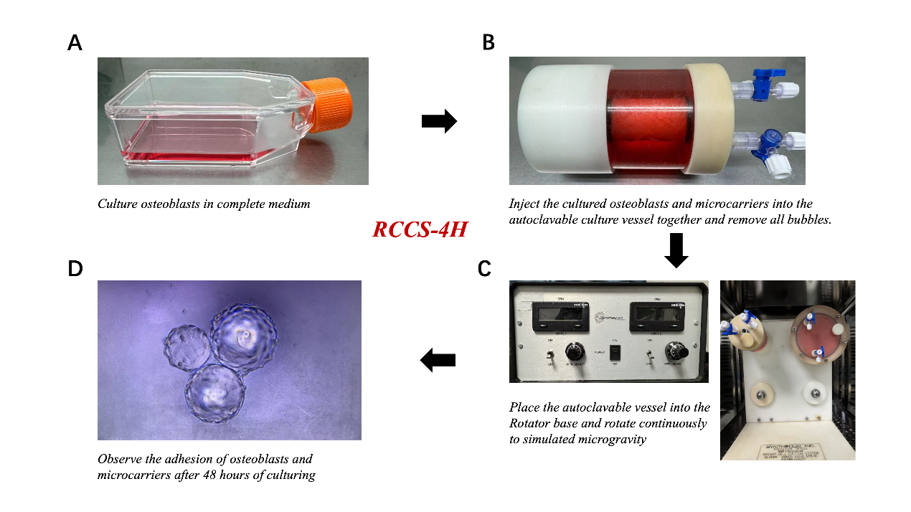
Supplementary Fig. 1. Establishment of an In Vitro Rotating Cell Culture Model. (A) Culture osteoblasts in complete medium. (B) Inject the cultured osteoblasts and microcarriers into the autoclavable culture vessel and remove all air bubbles. (C) Place the culture vessel onto the rotator base and rotate continuously to simulate microgravity using the RCCS-4H system. (D) Observe the adhesion of osteoblasts to the microcarriers after 48 hours of culturing.

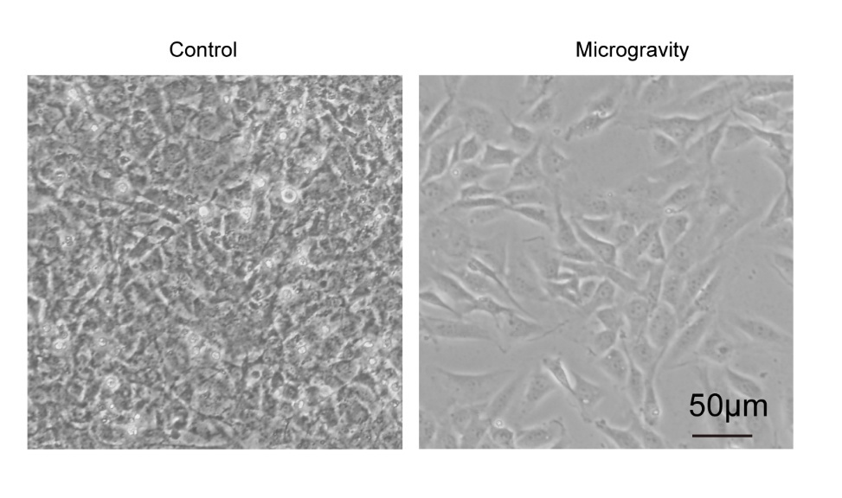
Supplementary Fig. 2. Morphological Characteristics of Cells Under Microgravity Conditions.

Supplementary Table 1. SiRNA Target Sequence.
Genes | Target sequence (5′-3′)
Si-Dnmt3a-1 | CGGACCACCTTACGTGACC
Si-Dnmt3a-2 | CAGTGGTGTGTGTTGAGAA
Si-Ddit3-1 | ATATAATCGACGTGTTAGGCT
Si-Ddit3-2 | TCAACATGATATAATCGACGT
SiNC | TTCTCCGAACGTGTCACGT

Supplementary Table 2. Sequences of qRT-PCR primers.
Genes | Primer sequence (5′-3′)
Col1a1 | F: TAAGGGTCCCCAATGGTGAGA
Col1a1 | R: GGGTCCCTCGACTCCTACAT
Bglap | F: GCAATAAGGTAGTGAACAGACTCC
Bglap | R: CCATAGATGCGTTTGTAGGCGG
Runx2 | F: GACTGTGGTTACCGTCATGGC  R: ACTTGGTTTTTCATAACAGCGGA
Dnmt3a | F: GATGAGCCTGAGTATGAGGATGG
Dnmt3a | R: CAAGACACAATTCGGCCTGG
Dnmt3b | F: CGTTAATGGGAACTTCAGTGACC
Dnmt3b | R: CTGCGTGTAATTCAGAAGGCT
Dnmt3l | F: TACGAAGTCAAAGTGAACCGAC
Dnmt3l | R: ACAAGGGGTGCCGAGTGTA
Mbd2 | F: GGAGGAAGTGATCCGAAAATCAG
Mbd2 | R: AGCATTTCCCAGGTATCTTGC
Mbd1 | F: AAACGCCGAGAGTCCTTTCG
Mbd1 | R: GCTCAACTTTGCTTCGGATCTTT
Ddit3 | F: GGAGGTCCTGTCCTCAGATGAA
Ddit3 | R: GCTCCTCTGTCAGCCAAGCTAG
Dnmt1 | F: AGAGACCAGGATAAGAAACGCA
Dnmt1 | R: CTCCTTTGATTTCCGCCTCAAT
Suv39h1 | F: CTGTGCCGACTAGCCAAGC
Suv39h1 | R: ATACCCACGCCACTTAACCAG
Tet1 | F: GCAGTGAACCCCGGAAAAC
Tet1 | R: AGAGCCATTGTAAACCCGTTG
Uhrf1 | F: CCACACCGTGAACTCTCTGTC
Uhrf1 | R: AGGCGCACATCATAATCGAAG
Gapdh | F: AGGTCGGTGTGAACGGATTTG  R: GGGGTCGTTGATGGCAACA

Supplementary Table 3. Summary of sequencing data quality and alignment statistics for RRBS and RNA-seq experiments.
Sample ID | Group | Assay Type | Reads (Pairs) | GC Content (%) | Q30 (%) | Mapping Rate (%) | Bisulfite Conversion Rate (%)
M1 | Microgravity | RRBS | 19,535,916 | 44.3 | 85.5 | 68.5 | 98
M2 | Microgravity | RRBS | 21,835,564 | 45.3 | 86.5 | 68.8 | 97.6
M3 | Microgravity | RRBS | 23,764,155 | 45.2 | 86.1 | 68.6 | 98.2
N1 | Normal | RRBS | 28,793,625 | 48.8 | 86.1 | 70 | 96.5
N2 | Normal | RRBS | 23,167,478 | 47.2 | 85.1 | 69.8 | 97.9
N3 | Normal | RRBS | 28,469,798 | 49.3 | 81.8 | 68.5 | 96.9
M1 | Microgravity | RNA-seq | 23,071,467 | 46.8 | 95.8 | 98.25 | N/A
M2 | Microgravity | RNA-seq | 24,368,444 | 46.8 | 95.8 | 98.31 | N/A
M3 | Microgravity | RNA-seq | 26,063,961 | 47 | 95.7 | 98.26 | N/A
N1 | Normal | RNA-seq | 23,624,918 | 47.9 | 95.8 | 98.25 | N/A
N2 | Normal | RNA-seq | 22,629,357 | 48 | 95.6 | 98.17 | N/A
N3 | Normal | RNA-seq | 21,821,490 | 47.1 | 95.7 | 98.14 | N/A

Supplementary Table 4. List of candidate genes exhibiting significant inverse correlations between promoter methylation and gene expression under microgravity.
Gene Symbol | Regulation Type | log2FoldChange (RNA) | padj (RNA) | Promoter Meth Diff (%) | Meth padj | Chromosome | Start | End
Ddit3 | Hypo-Up | 1.10 | 6.428E-36 | –19.9 | 8.18945E-05 | chr10 | 127288774 | 127290973
9330188P03Rik | Hypo-Up | 0.51 | 0.0103765 | –39.4 | 5.5905E-18 | chr14 | 105587476 | 105589675
Iah1 | Hypo-Up | 0.41 | 0.0076189 | –21.2 | 2.09341E-09 | chr12 | 21314389 | 21316588
Marcksl1 | Hypo-Up | 0.54 | 8.777E-07 | –18.1 | 2.28925E-32 | chr4 | 129511581 | 129513780
Slc22a23 | Hypo-Up | 0.46 | 0.0142849 | –15.7 | 7.4681E-133 | chr13 | 34344983 | 34347182
Dusp18 | Hypo-Up | 0.49 | 1.439E-06 | –15.2 | 5.33051E-14 | chr11 | 3893240 | 3895439
Rprd1a | Hyper-Down | –0.30 | 0.0324713 | 20.8 | 4.36069E-29 | chr18 | 24530005 | 24532204
Igf2r | Hyper-Down | –0.41 | 9.245E-09 | 21.2 | 1.74683E-11 | chr17 | 12769465 | 12771664

